Cast Shadow

📘 Definition
# Source: AI Source: Provided by: [Data Path: Persons Table -> ID Column: 1, Name_En Column: Motasem Essam] -> From: [ChatGPT] on [5/2/2026]
A Cast Shadow is the shadow that an object creates on another surface when it blocks light from a light source.

🌑 How cast shadows form
# Source: AI Source: Provided by: [Data Path: Persons Table -> ID Column: 1, Name_En Column: Motasem Essam] -> From: [ChatGPT] on [5/2/2026]
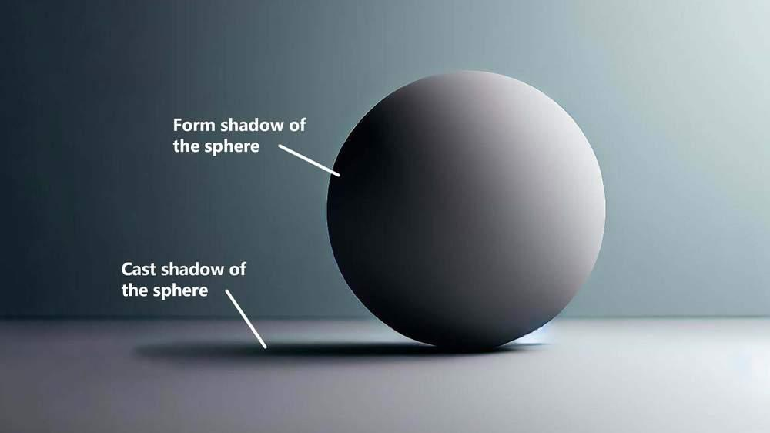
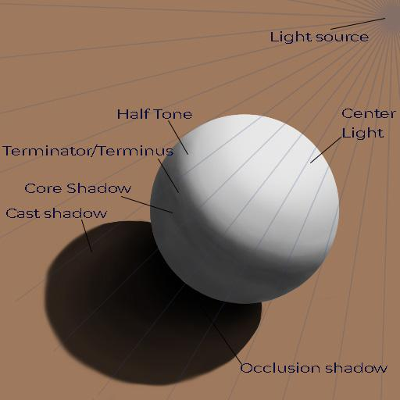
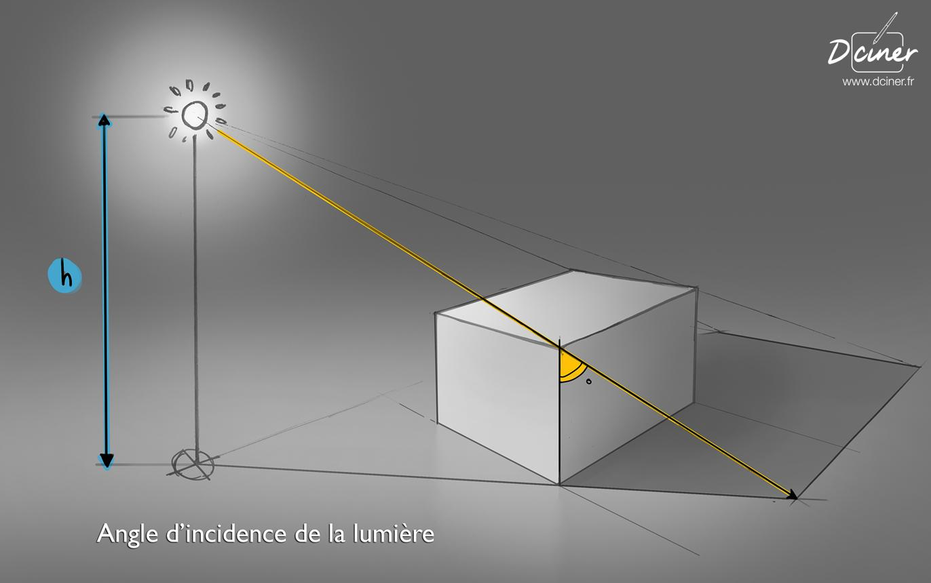
- Light comes from a light source
- An object blocks the light
- The shadow appears on a surface (ground, wall, etc.)

🧠 Simple example
# Source: AI Source: Provided by: [Data Path: Persons Table -> ID Column: 1, Name_En Column: Motasem Essam] -> From: [ChatGPT] on [5/2/2026]
Think of:
- ☀️ Your shadow on the ground when standing in sunlight
- 💡 A cup casting a shadow on a table under a lamp

🎮 Cast shadow in computer graphics
# Source: AI Source: Provided by: [Data Path: Persons Table -> ID Column: 1, Name_En Column: Motasem Essam] -> From: [ChatGPT] on [5/2/2026]
In graphics, cast shadows help show:
- 📍 Position of objects
- 📏 Distance between objects and surfaces
- 🌍 Direction of the light source

⚙️ Key features
# Source: AI Source: Provided by: [Data Path: Persons Table -> ID Column: 1, Name_En Column: Motasem Essam] -> From: [ChatGPT] on [5/2/2026]
- 🌑 Appears on a different surface, not on the object itself
- 📐 Shape depends on the object and light direction
- 🎯 Can be hard or soft
- 🧭 Changes with light angle and distance

🚀 In short:
# Source: AI Source: Provided by: [Data Path: Persons Table -> ID Column: 1, Name_En Column: Motasem Essam] -> From: [ChatGPT] on [5/2/2026]
Cast Shadow = the shadow an object projects onto another surface when it blocks light.

